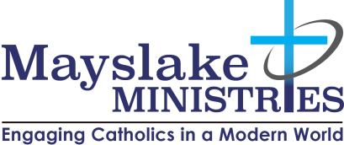
“Sacred Presence”
Spiritual Director Formation Program Application

*** NEW LOCATION: 1S314 SUMMIT AVENUE OAK BROOK TERRACE, IL ***
Name: _________________________________ Email Address: _____________________________
Address: __________________________________________________________________________
Home Phone: ______________________________ Cell:____________________________________
Parish or Church: ___________________________________________________________________
Candidate Application Instructions
- Complete and submit this Candidate Application to the Mayslake Ministries
Sacred Presence Program Director, Bob Frazee, bfrazee@mayslakeministries.org
- Include 2 personal references with your application (See form below) One from your current Spiritual Director if applicable
- Submit a non-refundable $100 application fee (Applicable toward program fees)
  - Application fee is payable to: Mayslake Ministries by check or credit card.
  - Please check your payment preference:
Check ____ Credit Card ____
Card # ___________________________ Exp.________ Sec # _____
- Once the completed application form is received & fee is paid: Mayslake Ministries will call you to schedule a personal interview.
Upon Acceptance into the program
Total Program Cost: $3,900 (Plus retreat expenses book and materials.)
- Fees may be paid in full ($3900) or in two installments of ($1950) Due: Sept. 1 & Feb. 1
or on a monthly basis with final payment due on or before June 1, 2023.
- Please Check one: Full Payment ______ 2 Installments ______ Monthly _______
Payment Preference:
Check ____ Credit Card ____
Card # ___________________________ Exp.________ Sec # _____

- Module materials will be distributed after receipt of payment(s).
- Retreats, books, & materials are extra.
- The program begins and ends with required retreat experiences. Candidates are responsible for retreat expenses.
  - All Day Program Orientation & Retreat (Sept. 9-10, 2022) 9-4 pm
  - Final Retreat & Certification Ceremony (June 24, 2023)
Program Modules
- The program consists of 6 Modules held at Mayslake Ministries
- Each Module is 6 weeks long with required weekly Cohort Sessions 7:00-9:30 p.m.
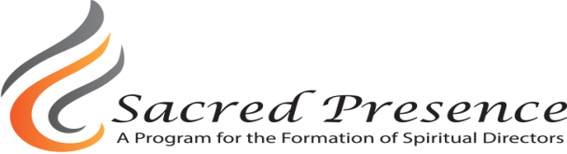
2022-2023 Program Schedule

Sept. 9-10 Orientation Time & Place TBD

Sept. 15 Skills Class

Sept. 22-Oct. 27 Module #1: Who is Jesus? What does it mean to be human?

Nov. 3-17 Module #2: What would Jesus have me do? Discipleship

Nov.24 No Class - Thanksgiving

Dec. 1-15 Module #2 Resumes

Dec 22 & Dec 29 No Class - Christmas Break

Jan. 5-Feb.9 Module #3: Healthy Human Development

Feb 13 First Draft of Spiritual Direction Model due

Feb. 16-Mar. 23 Module #4: Healthy Spiritual Development

Mar. 30 Module #5: The Function of Spiritual Direction: Discernment

April 6 No Class - Holy Week

April 13-May 11 Module 5 resumes

May 15 Second Draft of Spiritual Direction Model due

May 18- June 22 Module #6: Living the Christian Life in the Modern World

June 23 Final write-up of SD Model

Sat. June 24,2023 Final Retreat and Certification Ceremony

Bob Frazee Dr. Mary Amore, Executive Director
Sacred Presence Program Director Mayslake Ministries

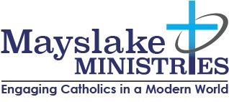
Candidate Application Questions
Directions: Complete each of the following questions. Limit your answers to 200 words. Please submit your typed answers by July 31, 2022 to the Program Director Bob Frazee by email bfrazee@mayslakeministries.org or mail to: Bob Frazee c/o Mayslake Ministries 1S314 Summit Avenue Oak Brook Terrace, Il 60181

1) What has drawn you to the ministry of spiritual direction at this time in your life? What faith and life experiences have attracted you to seek training in spiritual direction?

2) How would you describe the role of a Spiritual Director? What specific skills must a Spiritual Director master in order to be effective in their ministry role?

3) What ministerial or pastoral formation/education have you had? How has this training led you to companion others in faith? How have people sought you out or come to you for guidance?

4) Describe your private and communal prayer life. How much solitude and silence is involved in your prayer life? How do you nurture your inner-life in order to continually deepen your spirituality?

5) What personal qualities and strengths do you bring to spiritual direction? In what areas do you need to grow?

6) Describe any experience in which a person sought you out or came to you for guidance? What did you learn about yourself from the encounter?
Note: A personal interview is the final step in your application process. Mayslake Ministries will call you to schedule your interview.
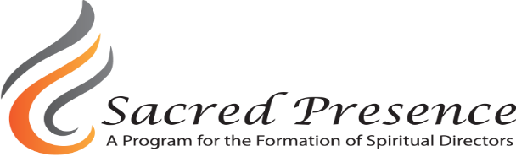
Candidate Reference Form

Candidate: Please ask your 2 references to email or mail the completed form below to:
Bob Frazee
bfrazee@mayslakeministries.org
Mayslake Ministries 1S314 Summit Avenue Oak Brook, Il 60181 630-852-9000

Your Name:_________________________________Title:_______________________________ Phone:_____________________ Date:___________ Candidate’s Name___________________
- What is your relationship to the candidate and how long have you known them?

- Describe the candidate’s faith life and practices.

- Comment on the candidate’s ability to deal with hardship and suffering in their own lives and in the lives of others.

- How does this candidate demonstrate openness to others?

- How have you experienced this candidate nurturing him/her self?

- What evidence have you seen that this candidate is capable of serving as a spiritual companion to others?
